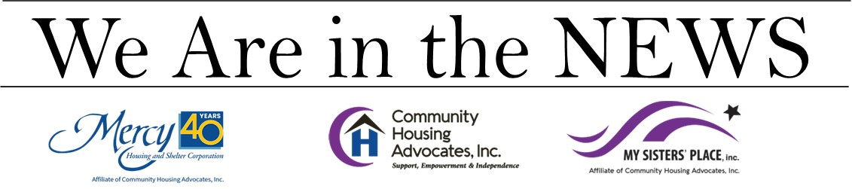
HARTFORD COURANT
May 24, 2023
Homeless services aren’t what they used to be. And that’s not necessarily a bad thing. When I first started working in homeless services in the mid- 90s, the scarce services available were at best disjointed and difficult to navigate. The saying was that we were funded to provide “three hots and a cot,” referring to three hot meals and a safe place to sleep. If you became homeless, you received additional help only if you were lucky enough to land in a shelter that offered case management services.
When nonprofit, private and government leaders from around the state gathered about 25 years ago, it was decided that we can end homelessness. There was recognition that the way we were providing the services would not get us to that goal, which resulted in launching a series of advances in homeless services. This was done through hard work and implementation of more effective policies and practices, resulting in the emergence of Connecticut as a national leader in creating innovative homelessness services.
Through private and public partnerships, we started to provide affordable housing along with case management (known together as “Permanent Supportive Housing”) to those with disabilities. Simultaneously, we worked on Transitional and Rapid Rehousing, aimed at helping those who were able to exit shelter quickly and move into apartments in the community. We then implemented a system of Coordinated Access Networks (“CANs”). The CANs ensured that if someone became homeless or was at risk, they could call 211, which would help them find appropriate shelter, based on the families’ or individuals’ needs. In 2016, Connecticut was the first state to effectively end veteran homelessness, meaning that if a veteran became homeless, a shelter bed would always be available and that veteran would be placed in their own housing, with their own lease, in two weeks or less. This still holds true today. Diversion services were then introduced to prevent people from becoming homeless by first determining the factors causing their housing instability and then providing resources to help keep them housed.
And it worked. Until it didn’t.
In spite of being successful in preventing homelessness and quickly helping people who become homeless find housing, today the majority of people in shelters are the most medically fragile, ranging from physical to mental illnesses to substance abuse challenges. This vulnerable population is the most challenging to help find and maintain stable housing. All of these challenges have been exacerbated by COVID.
This acute population cannot be helped by volunteers or housed overnight in church basements. This population deserves to be helped with clinically knowledgeable, well-trained, and well-paid professional staff. Unfortunately, homeless service providers cannot afford to pay this kind of professional staff, because of the financial limits of our state contracts.
Neither should the sole responsibility to care for these citizens fall on homeless service providers. We need the continued support of our dedicated donors, our volunteers, and the municipalities in which we work, and support from surrounding communities, whose citizens we help. Homelessness is not exclusively an urban problem. When people who live in the suburbs and in rural areas become homeless, they come to the cities for help.
Because homelessness is a statewide problem, we need support from our state budget. Currently, there is no funding in the proposed FY24-25 budget to increase wages for the professionals who do this demanding work. Nor is there funding to open cold weather shelters, which are the shelters that open in the winter when the year-round shelters are full. In a year when we have budget surpluses, we are asking for an increase in the state budget to financially support our staff and cold weather shelters. We need this additional funding to help a more fragile population find safe, secure housing.
We can fix this. Our legislature and our governor can fix this by ensuring there is funding in the state budget to help individuals and families who are experiencing a housing crisis — homelessness. Let’s not go back to the failed homeless services of the last century. Together we can move forward and do better. Together, we can end homelessness in Connecticut.
Kara A. Capone is chief executive officer of Community Housing Advocates, an affiliate of Mercy Housing & Shelter Corp. and My Sisters’ Place.

