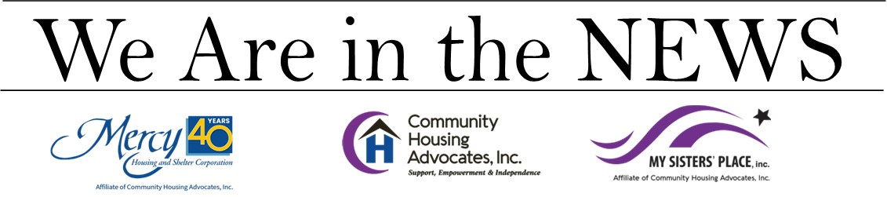
HARTFORD COURANT
June 2, 2023
$8M affordable housing project is coming to Hartford. ‘One tool in our toolbox to end homelessness’
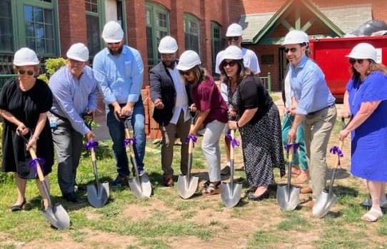
Staff, Partners, and Supporters at the groundbreaking ceremony for 102 Pliny Street in Hartford, which will be renovated to create 24 new affordable housing units for families and individuals in need of housing.

By DEIDRE MONTAGUE | dmontague@courant.com | Hartford Courant
PUBLISHED: June 2, 2023 at 7:10 a.m. | UPDATED: June 2, 2023 at 9:14 a.m.

HARTFORD —There was a celebration at My Sisters’ Place as CEO of Community Housing Advocates Kara Capone made the official announcement of a multi-million dollar renovation project at a property owned by the local organization.
The $8 million project at property owned by My Sisters’ Place at 102 Pliny St., includes the building being gutted and completely renovated to create 24 residential units of affordable and supportive housing for unhoused families and people in need, according to the organization.
The building has been vacant since 2017 and the renovations are expected to be completed in a year. Capone said that, as a part of the organization, the building has served the community well over the years and has been a shelter for women and children, a safe haven for women experiencing domestic violence, a women’s recovery program, and transitional housing for homeless families.
“Following a new tradition of service, our building will remain and be reimagined to meet the growing need for housing for homeless families by upgrading to 24 new units of affordable housing,” she said.
My Sisters’ Place was founded in 1982 as a shelter for single women and women with children who had no other housing options. The organization then expanded to provide housing and supportive services for those in need throughout Greater Hartford.
Capone said the organization’s other apartment building across the parking lot at 76 Pliny St. currently has 34 affordable housing units, where they have shared resources between youth programs, community computer labs, property management, case management, and other community resources in the area, all of which future residents would also have access to.
“With proximity to Albany Avenue, all the residents have access to public transportation, community health centers, the YMCA, grocery shopping, all of those things that make community what it is, those things that bring us together,” she said.
She said she thanks funders and partners who helped make the renovation possible and understood the need for this type of housing and development.
Funding for the $8 million dollar project came from a variety of federal, state, and local resources with significant support from the Connecticut Department of Housing, she said.
Her partners include the U.S. Housing and Urban Development, Connecticut Department of Housing, Eversource, Connecticut Housing Finance Authority, The Corporation for Supportive Housing, Hartford Foundation for Public Giving, the city of Hartford, Mayor Luke Bronin, the Connecticut Department of Mental Health and Addiction Services, and the Neighborhood Revitalization Zone.
Capone said the organization has done a lot of work over the years to reduce homelessness, yet they have more to do.
“In 2021, over 2,500 people in the state of Connecticut were counted as being homeless on one day in January, that’s 2,500. That’s just a snapshot of who is homeless in the state. Of those individuals, almost 400 are homeless in Hartford. Important, so we have a need in this community,” she said.
“We’re currently seeing increases in homeless families, and homeless elderly (individuals). This is a trend that’s also being seen nationally, so we’re trying to keep up with those trends and figure out how we can also provide services to those populations…by developing housing like this is one tool in our toolbox to end homelessness,” she said.
Connecticut Department of Housing Commissioner Seila Mosquera-Bruno said that working to prevent homelessness is a major priority for her.
“Nobody deserves to be in a shelter, especially kids. Prevention for us is big – for me, especially. I don’t want to see kids in a shelter,” she said.
“We’re doing things besides development, besides providing resources to the shelters… we’re just wanting to make sure that we put the resources where they are needed…to make a difference,” she said. “So for me, this project is awesome. Looking forward to coming back for the grand opening…And we’ve said we’re going to continue the work of these types of projects.”

